**Section B: AWS Questions**

1. **If i have workload with memory centric, what ec2 instance type must i choose ?**

Any EC2 instance that includes in memory optimized section, like :

* X1
* High Memory
* Z1
* R5

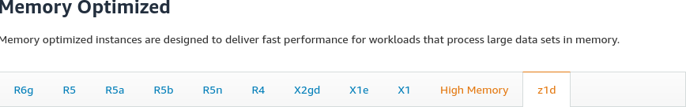

1. **I have two instances, deployed in same region and same availability zone, what else should  i do to reduce latency between this instance ?**

Setup the placement group , so the instance can be on the sampe partition

1. **If you have two VPC, how to connect them ?**

There are some method to connect VPC :

* Using VPN
* Using VPC Private Link
* Using VPC Peering
* Using VPC Transit Gateway

1. **How to make private subnet on VPC can access the internet ? explain the steps  in details.**

Assumption : VPC already setup

Answer:

* Setup elastic IP
* Setup the gateway
* Setup NAT
* Attach NAT from gateway to private subnet

1. **If you create External Load Balancer (ELB), what subnet must attach to this Load Balancer to make it accessible from Internet ?**

Assumption : Only makes ELB can be accessed from public, other private networks are not includes

Answer

The public subnet must be attached to ELB

1. **Which one is fast ? ALB or NLB, explain why.**

Both are fast in different ways and their usage, ALB is fast when it comes to using Layer 7 (apllication or HTTP/HTTPS) but it’s can’t served other layer, while NLB serve on layer 4 on IP based route. SO it’s depends on what layer is your application works.

1. **Whats is the difference between S3 and S3 Glacier ? and when to use them**

**S3 gives more speed and lower latency, while S3 Glacier gives more cheaper and larger storage.**

Use S3 if we need low latency or frequent data access , while we can use S3 Glacier for data or backup which does not need fast speed

1. **What is the difference between EBS and EFS ?**

EFS can be mounted from different region while EBS can only be mounted from single EC2 instance on same region

1. **I already have SSL certificate and key, what AWS service must i use to do SSL termination on ELB ?**

SSL termination can be done in first wizard of ELB on SSL menu